LOCATION |  | INTERSECTION AREA | REPORTED BY |  | ISAAC KUMAH
COORDINATES |  | 5.0030360, -2.2493880
DATE |  | 03 AUGUST 2026 | TIMES REPEATED
TIME |  | 1221HRS | CATEGORY |  | ILLEGAL MINING/ENCROACHMENT
REF. NUMBER |  | SEC-INC030826 | DEPARTMENT |  | SECURITY

On Monday 3rd August 2026, at about 1221hrs, the Day Security Operations Team during their routine patrols visited Coordinate: 5.0030360, -2.2493880, Intersection Area and dismantled one (1) changfan machine and one (1) washing board in situ.

Routine patrols will be intensified in the general areas to ward off intruders on ARL concessions.

Photographs
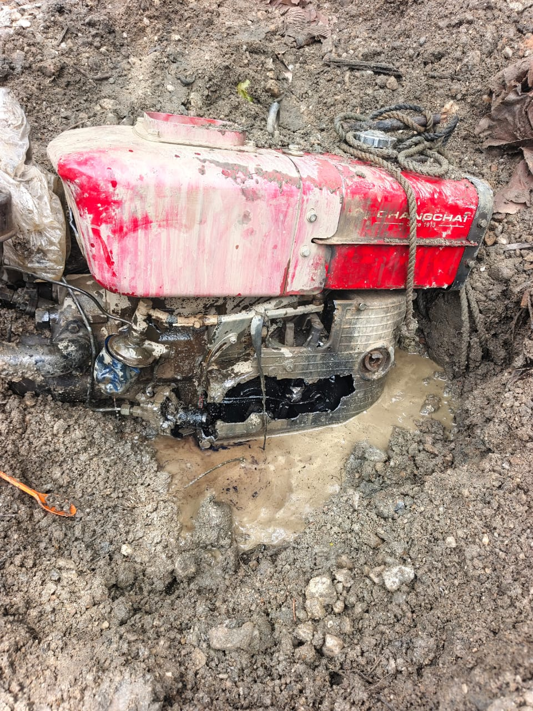 | 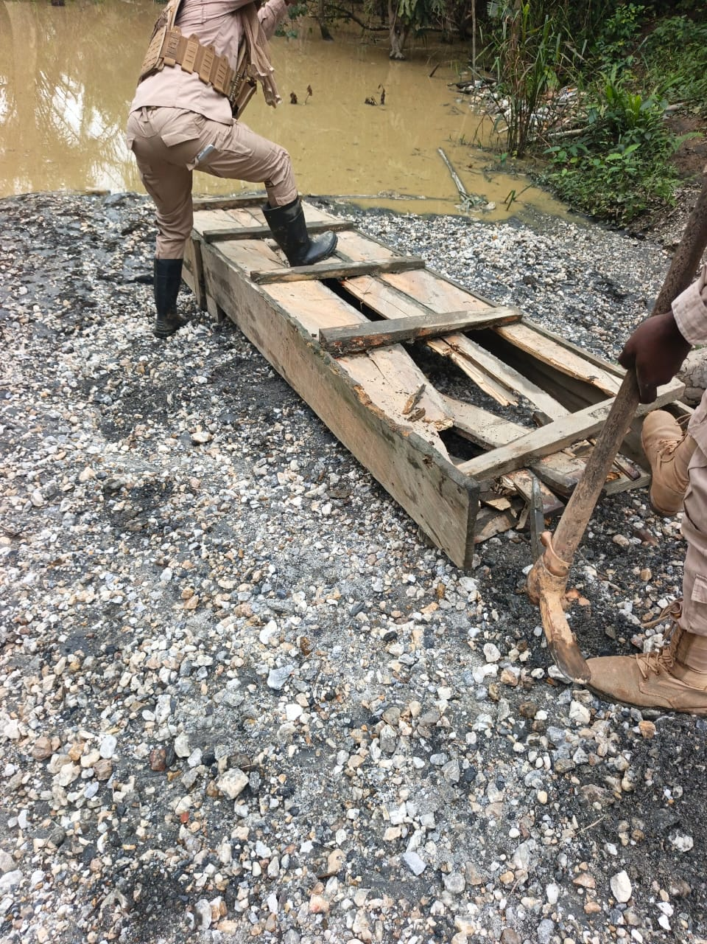
Dismantled changfan machine and washing board – Intersection

(SOURCE: ARL SEC 2026)

S/N | HOT SPOT AREA | ACTION TAKEN/REMARKS
1 | Aliva Central / South / Atababo / Laydown | NTR
2 | Boanome/Nfutu (South/North) | NTR
3 | Adamus Pit/Laydown | NTR
4 | Sanu | NTR
5 | Nugget Hill/Teburu | NTR
6 | Salman North (03 and 04 Pit) | NTR
7 | Akango 04 Pit/Fishpond | NTR
8 | Akango South/Far North | NTR
9 | Akango East | NTR
10 | Akango North | NTR
11 | TSF | NTR
12 | Anloga/Obengkrom | NTR
13 | Ankagyare | NTR
14 | Salman Old Community Mining/ Salman (East/South/Central) | NTR
15 | Intersection | One (1) changfan machine and one (1) washing board dismantled. - Intersection
16 | Snack Pit | NTR

